An Archive of Love
A Tribute to Edelmira Alers, also known as Esther, Ita and Mom
May 29, 1949 - April 17,2020
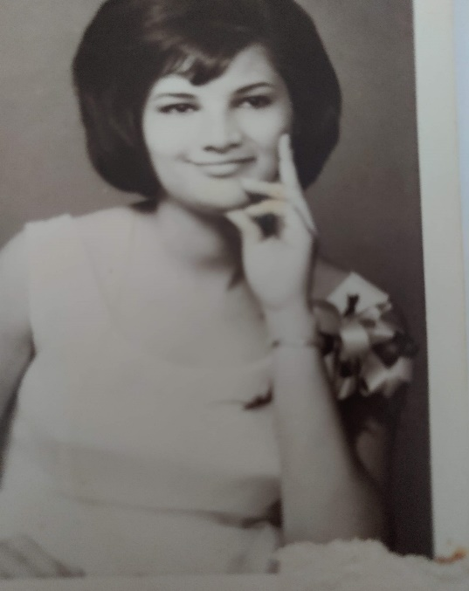

The way to change a tragic drama back into a heroic one is to open the secret, speak of it to someone, write another ending, examine one’s part in it and one’s attribute in enduring it. The having lived through it is a triumph of the deep and wild spirit.
Dr. Clarissa Pinkola Estes,
excerpt from Women Who Run With the Wolves

Nothing has a stronger influence psychologically on their environment and especially on their children than the unlived life of the parent.
C. J. Jung

You need to claim the events of your life to make yourself yours--- Anne Wilson Schaef

Before You Were My Story, You had A Story of Your Own

Before you were my mother, you were a child. A girl
in the mountains of San Sebastian, Puerto Rico
where you lived till you were five years old. You told me only the one story.

To honor the life of my mother,
I must first declare we are forgiven.
I forgave her for not having been able to give me
what she had not been able to give herself.
She forgave me,
though she swore there was no need and I was perfect,
we both knew it wasn’t true.
I was as strong and fierce as she was,
and it often meant
that I was responsible for long separations during our adult lives,
similar to the ones I endured as a child and a young adult from her.
We both learned that leaving is sometimes a form of survival.
In the end we were battle weary but even,
Not even like revenge, but even like the balance game on a home made seesaw she would play on with her sister, my Aunt Connie.

It was a plank of wood over an old coffee can, and they would jump up
then pull each other down till they were covered in mud.
Their parents, Ventura y Gloria, had left them with Abuela Carmela,
who adored them. They were there, with her and without them, for two years, unsure as all young children are when their parents disappear, but
surviving like all children do, playing games and clinging to each other.

It is the only story I know of her life in the mountains of San Sebastian that I know and love so well.
Then there is the story of the day they get picked up and flown to New York with Abuela Quintina, their other grandmother whom they had no memory of, and who scared them with her big black hat and high heels.

For me, my mother’s life begins in New York,
but in fact, it began in the mountains of Puerto Rico covered in mud,
playing and laughing with her sister,
while quietly missing her mother, as I would one day miss her.

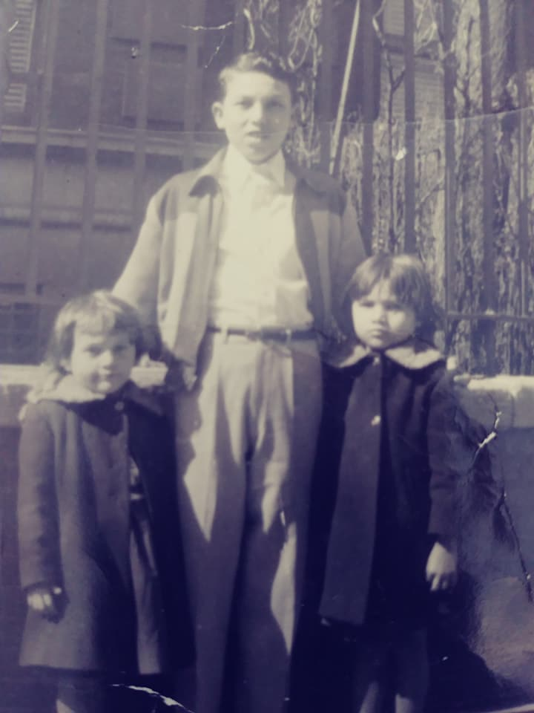 New York City, My Mother on the right, My Aunt on the left. 1965

What can I know of your pain and your suffering
Only the fragments
The accident when you were only six years old
The skin rashes that tormented you
The leaving of home and language and home made seesaws
For an unforgiving city that was cold, it was always so cold
Your little legs covered in goosebumps
Darting out from under the coat
Reminding you of all that had been lost

What I know is of your survival
In so many ways
Written along my body, inscribed in my DNA
The marching orders are clear
Never retreat, never relent
Survive
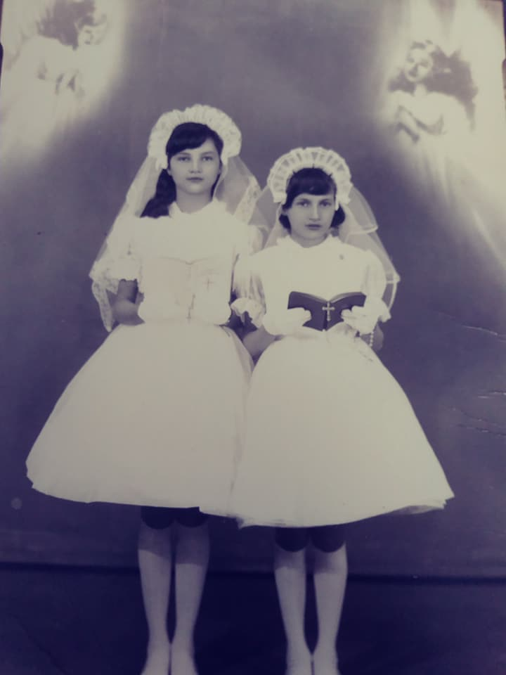
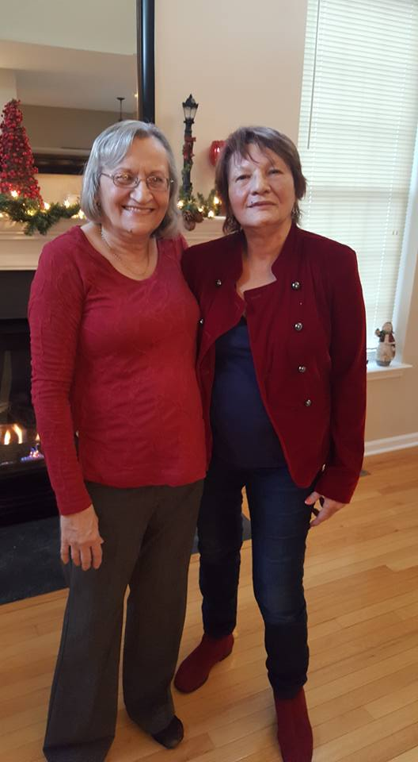

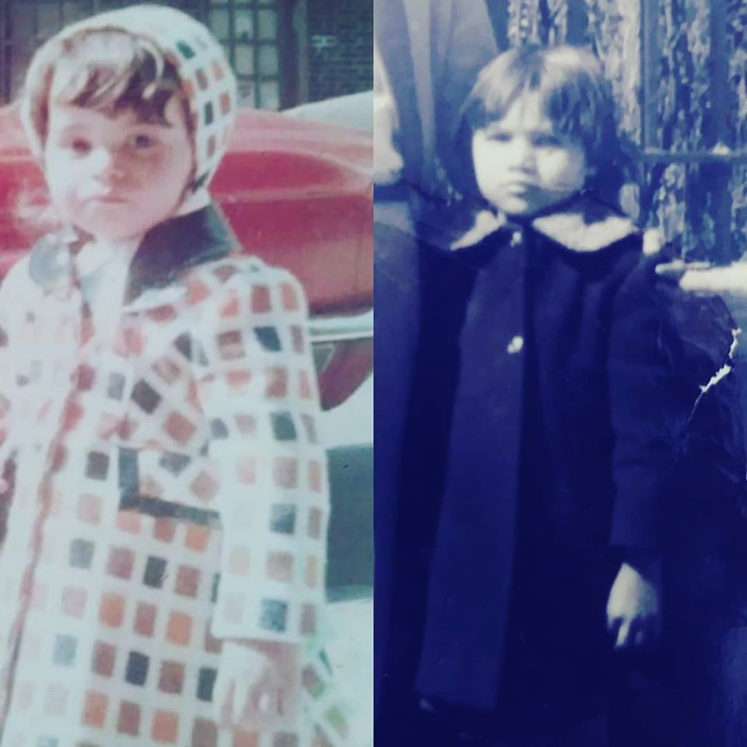 Me on the left, my mother on the right

Mercedes, Gloria,
and Edelmira

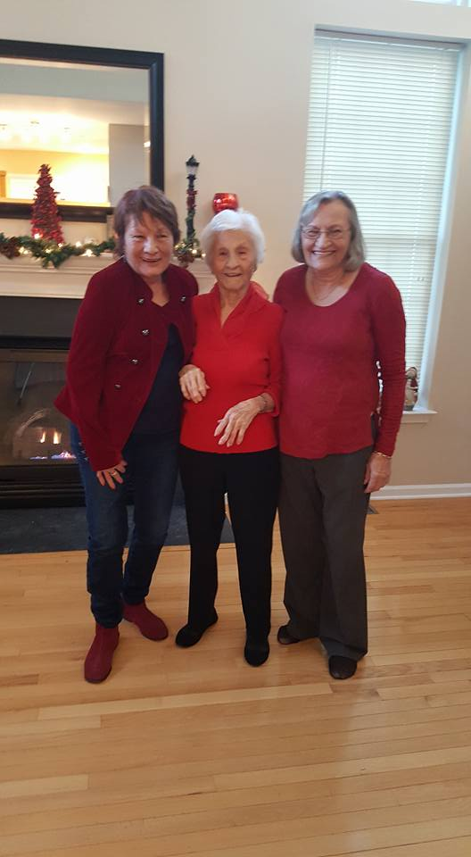 Together
We are all forgiven
All of us
and released into the joy of knowing
We did not give up
On living, or on each other
We did not relent\We did not retreat
The whole of this matrilineal line healed by perseverance and a willingness to try again.
One more time,
More forgiving,
More generous of heart,
More accepting of all of our imperfections and bad choices
Able to heal and love and celebrate even the impermanence of things
Which is the only truth
We are all forgiven, and impermanence guarantees
that not even our suffering will last forever, but our survival marks the world with how we mattered

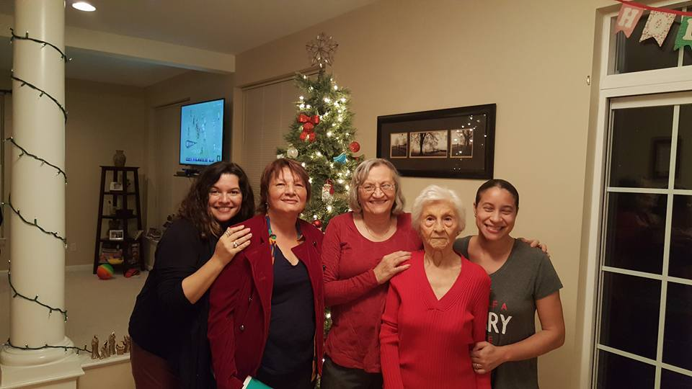
You mattered and were loved and will never be forgotten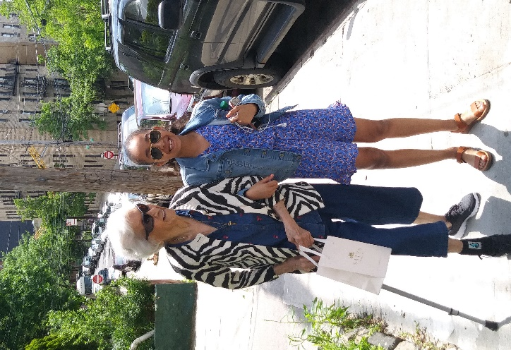
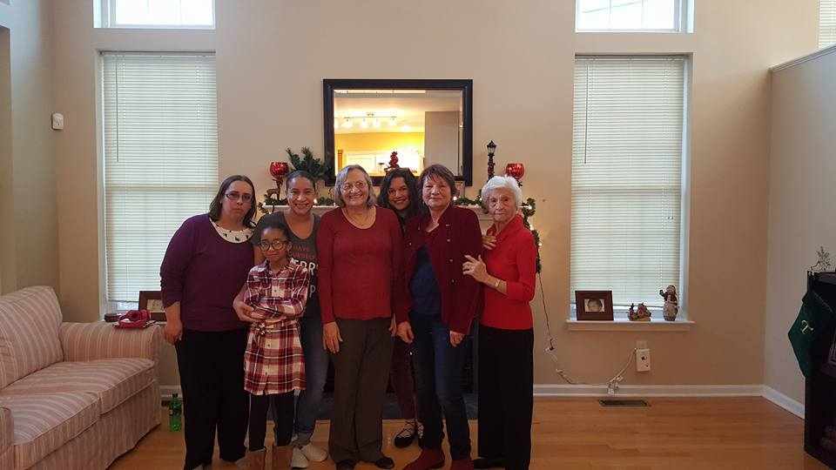
My mother loved music, family, parties, good food, dancing and flowers. She loved her grandsons. She loved us all, and we love her. To memorialize a mother we must neither make her a saint or a demon, Neither perfection or absolute evil will do. We must make of her a human who loved, and remember her through that love. I love my mother and she loved me and We Are All Forgiven.
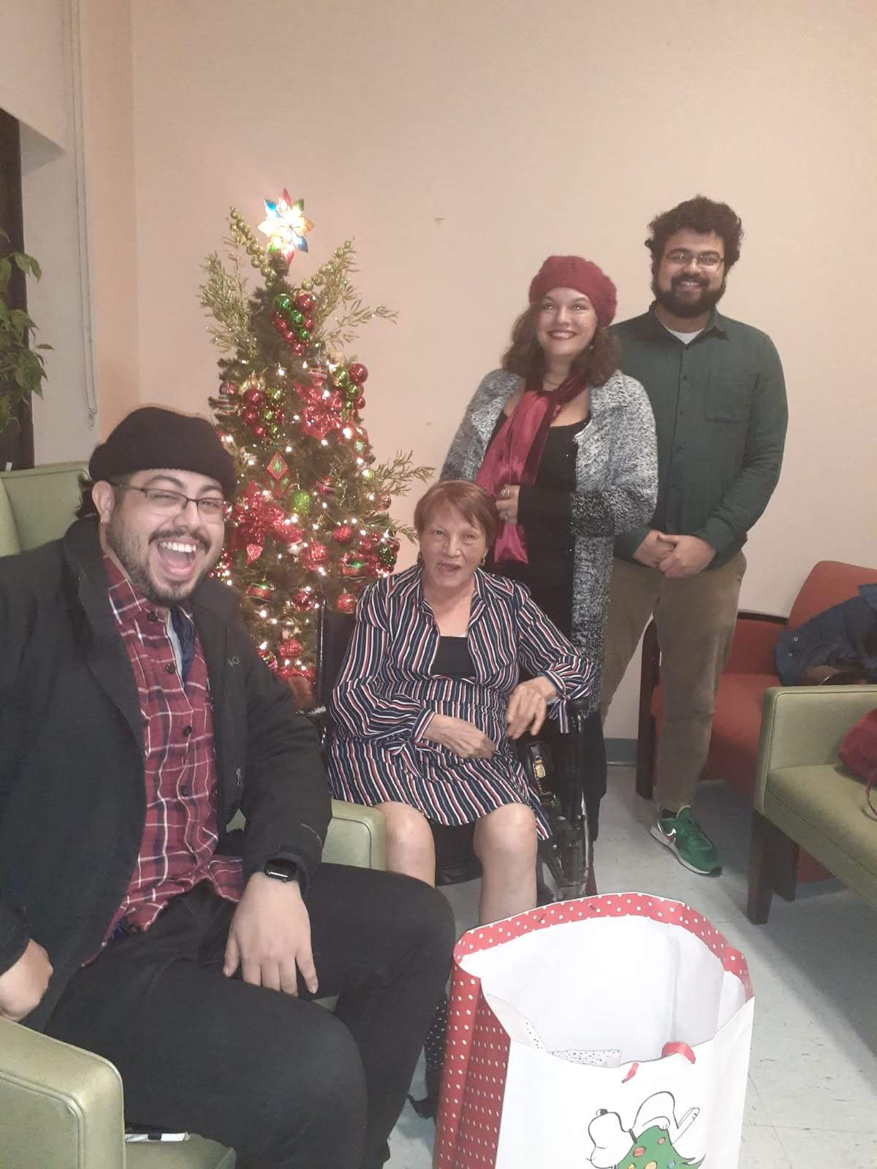
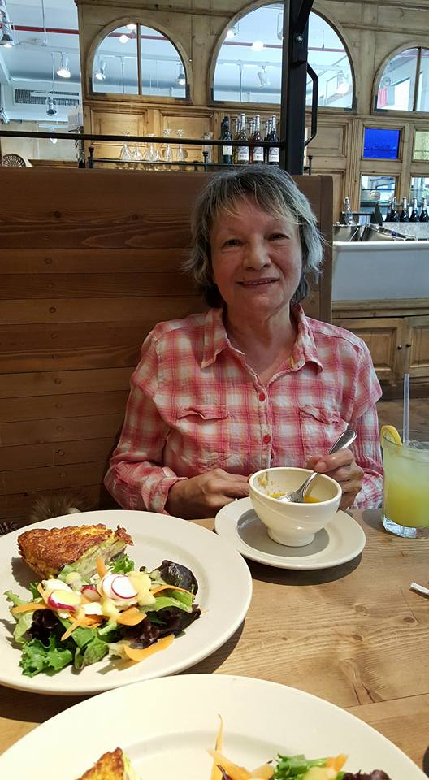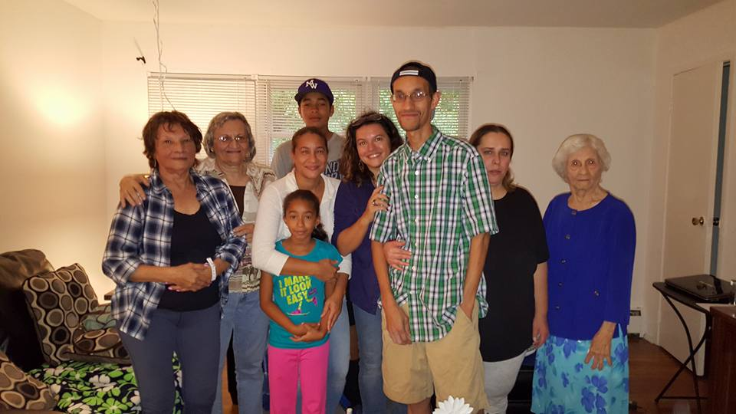
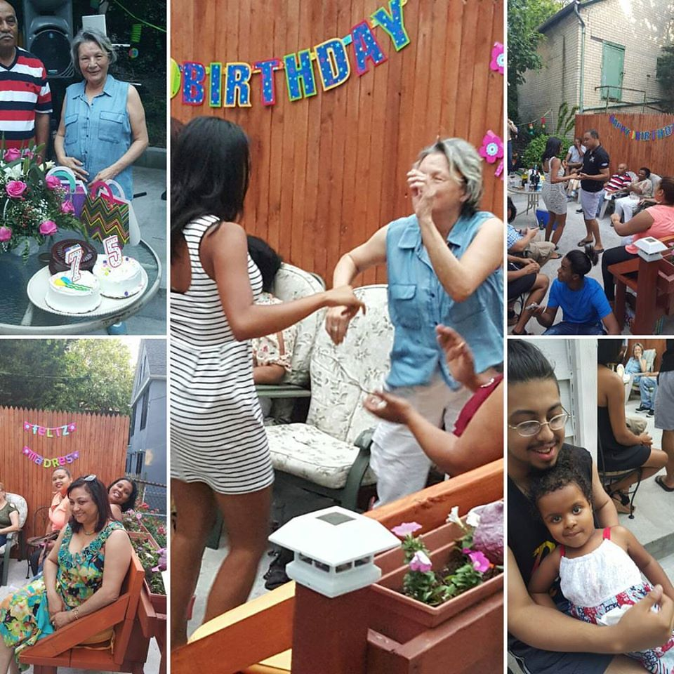

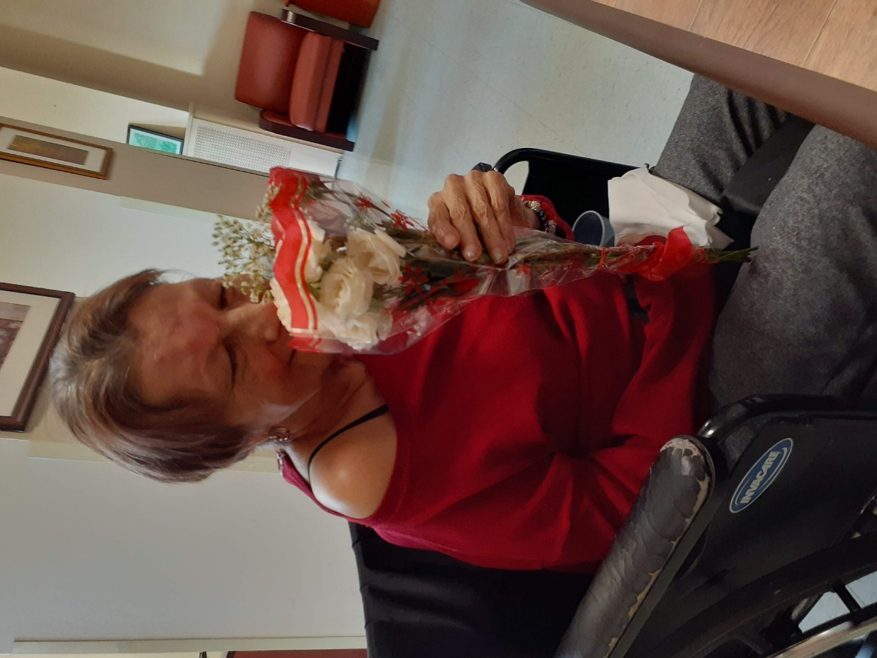
Taken on Valentine’s Day February 14, 2020. Taking time, still, to smell the roses.

